Day in the Life of the Hudson River 10/13/22
Schodack Island Preserve, Schodack Landing
RIVER MILE: 134.5
Salt Front: ~ RM76
Columbia County Soil and Water CD - Leanna O’Grady
Ichabod Crane High School – 14 students & 3 adults
Latitude - 42.499487°N & Longitude - 73.776702°W
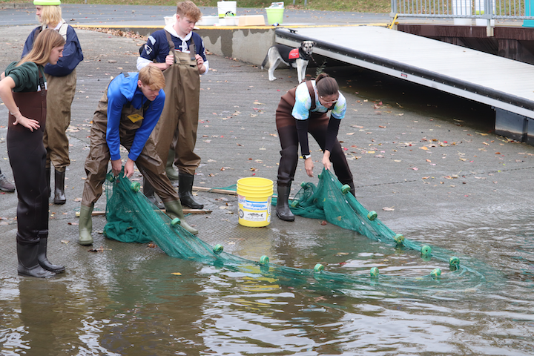 | 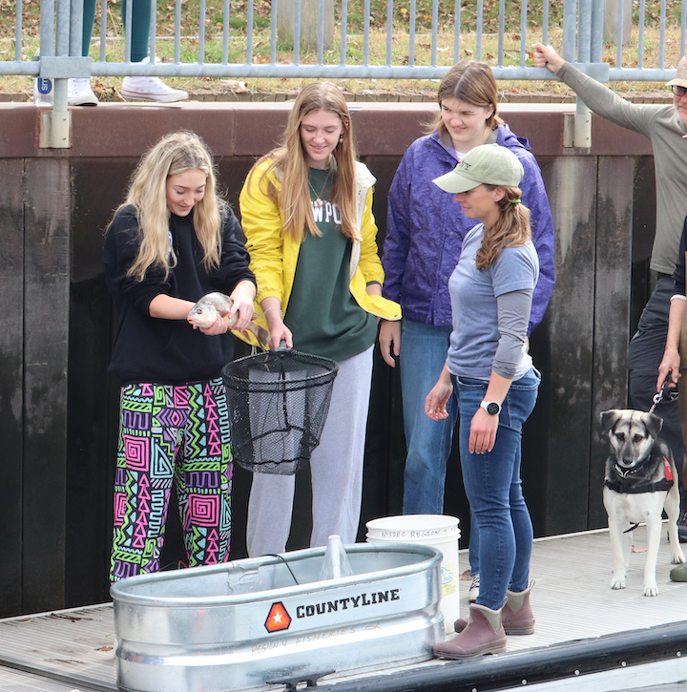 | 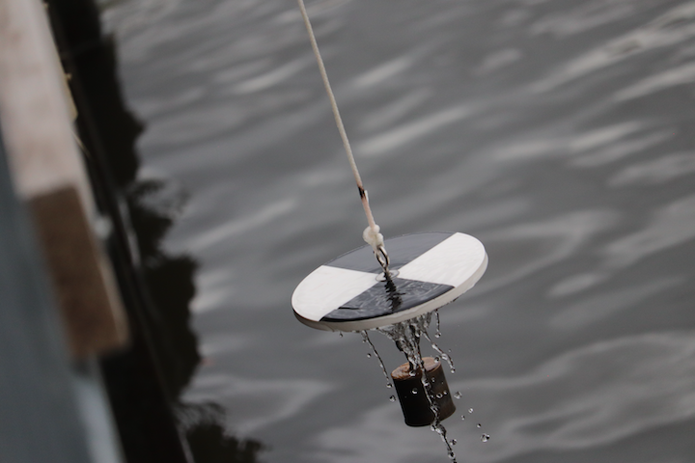

Location: Schodack Island State Park, Schodack Landing, Rensselaer County, NY
Area: 1052 acres- park and boat launch area- grassy area with concrete walkway, pier, forested, grassy, parking lot and boat launch
Sampling Site: Boat launch, banks altered, covered in vegetation, riprap, concrete bulkhead, pipe entering the water
Surrounding Land Uses: 70% Forested, 15% Urban/Residential, 55% Industrial/Commercial
Shoreline: 5% Sandy, 15% Muddy, 80% Rocky
River Bottom: Rocky, Muddy
Water: NR
Plants in the Water: no plants
*NR = Not read/recorded
ITEM |  | Time |  | Reading |  |  |  | Comments
Physical
Air Temperature- |  | 11:00 AM |  | 16°C |  |  | 60.8°F
Wind Speed: |  | 10:58 AM |  | Anemometer  1-3 knots |  |  | Beaufort  1 | Direction  S
Weather today |  | 10:45 AM |  | >75% cloud cover |  |  | Start & Stop
Weather the past 3 days: |  | No rain, no unusual wind or temps
Tides- |  | Time |  | Rising, Falling, Unchanged |  |  | Water Height (cm)
 |  | 10:45 AM-12:30 PM |  | Falling the whole time |  |  | NR
Current- |  | Time |  | Cm/sec |  | Knots | North/South | Ebb/Flood/Still
 |  | 10:40 AM  10:43 AM  11:30 AM |  | 20.8  30.45  15.63 |  | NR | NR | Ebb
Water Temperature- |  | 10:55 AM |  | 15°C |  |  | 59°F
Turbidity- Secchi Disk (cm) |  | 10:45 AM |  | 133.3 cm
Chemical
Salinity-LR Quantabs |  | 11:01 AM |  | 63 ppm |  |  | LR Qauntab 1.6 | 35 ppm Cl-
Standardized Salinity – LR Quantabs* note the unit conversions are matched to the batch of quantabs |  | 10:49 AM |  | 65 ppm |  |  | LR Quantab 1.6 | 36 ppm Cl-
DO – Lamotte Drop Count Kit |  | Time  10:40 AM |  | Temp  15°C |  |  | ppm DO  10.2 ppm | % saturation  100%
pH – pH pen |  | 10:50 AM  11:50 AM  11:53 AM |  | 6.3 *note fairly low  6.8  7.0
Nitrates- NR
Phosphates- NR
Alkalinity- NR
Biological-
Fish – Seine – 2 pulls |  | Number |  | Name |  |  | Length of longest | Length of smallest
10:30 AM-12:00 PM |  | 10  1  15  23  1 |  | Blueback Herring  Golden Shiner  Spottail Shiner  Banded Killifish  Striped Bass
Fish Totals |  | TOTAL: 50 |  | Diversity: 5
Macroinvertebrates |  | Number |  | Name |  |  | Length of longest | Length of smallest
Macroinvertebrate Totals |  | TOTAL: 0 |  | Diversity: 0
Sediment Core – NR
Length | H2S smell |  | Oxid Top |  | Oil |  | Grain Size | Other Features
Boats- NR
 | Time |  | Name |  | Color |  | North/Southbound | Light/Loaded
Commercial | 12:40 PM |  | Edwin A Poling  Being pushed by Kimberly Poling |  | White & teal |  | North | loaded
Recreational | 10:45AM |  |  |  | White |  | South
 | 11:15AM |  | DEC |  | Grey |  | North
 | 11:54AM |  | Riverkeeper |  | White |  | North

